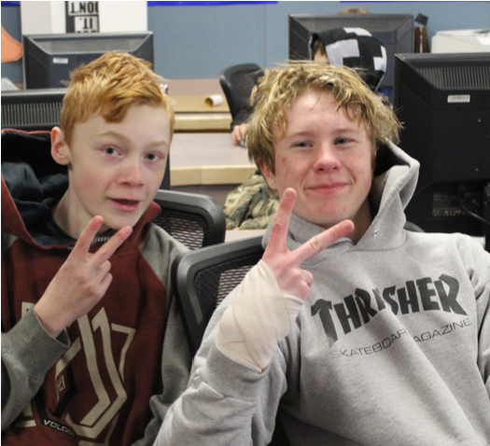

Grade 7 Parent and Student Open House

Grade 7 Parents and Students are invited to an information evening that will include:

* Open House (approximately 1 hour)
* Grade 8 Course Selection
* Presentation from various departments
* Question and Answer period

DW Poppy Secondary

Date: February 20, 2020

Location: Dramnasium

Open House: 6:00 pm- 7:00 pm

Presentation: 7:00 pm - 8:00 pm

Contact: Mr. Powell , Vice Principal

APowell@sd35.bc.ca

604-530-2151

